
Core Purpose
To Love all people into a community of Christ-like Disciples

Southside Nazarene Church exists in order to fulfill the Great Commission and Great Commandment of Jesus Christ.

Core Vision
Southside Nazarene Church
Chesterfield, Va.

We are a growing, Christ-centered, Bible-based church in the Richmond area known by:

The Way We PRAY
Daily practicing dynamic personal communication with God

The Way We LOVE
Passionately loving God and people

The Way We LIVE
Faithfully living so the leadership of God’s Holy Spirit is evident in our worship, lifestyles, and attitudes

Core Strategic Vision

To be a Multi- Organizational, Multi-Campus Purpose-Driven church of small groups. That works together to reach 2% of the lost while: Empower lives in our Community!

- We Dream: of five campuses, geographically located, where people can worship the Lord within 22 minutes of their neighborhood and be able to invite their un-churched neighbors.
- We Dream: that every neighborhood around our five campuses have small groups offered each night of the week, giving options for people to grow.
- We Dream: each campus having seven-day-a-week ministry facilities that offer multiple opportunities for the people to connect with us. We plan to open these facilities to the community, designed so that all ages can be ministered to regularly through a variety of opportunities for growth and development.
- We Dream: of a central support system that equips each campus for success with ministry development, administration, and facilities for big events and activities for the community at large.
- We Dream: Through our ministry partner GCA, we will provide Daycare, Preschool and a Christian School, and where facilities are available, have a daycare at each campus.
- We Dream: Through our Ministry partner Footsteps Counseling, we have available counseling services to help those who need restoration and healing for mental, emotional, and spiritual health.
- We Dream: Through our partner XZone, we will offer an after-school and sports program to connect our community. Our partnership with XZone will be expanded as we grow and expand the Courthouse Road campus.

Core Strategy

We recognize that living Jesus’ mission for us as people and as His church is a lifetime journey, not a momentary decision. So to that end, we have structured the process of becoming disciples and making disciples in a way that we hope is faithful to the Gospel of Jesus.

Our Discipleship process is to Reach our community (people on the Freeway of life) and Connect them to authentic Worship (invite them into our foyer) Connect them to a small group for Growth (live with them in the family room) and help them find their place in Service (join them in the kitchen)

Profile of a Christ-like Disciple

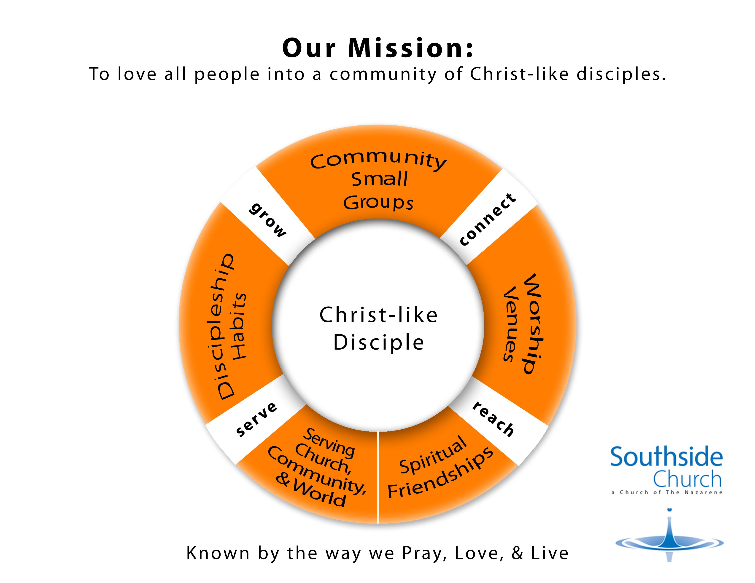

Core Values

Everyone’s Life Matters

People matter to God, so we engage individuals where they live and lead them to Jesus Christ.

We Are Created For Intimacy with God

Intimacy with God is accessible to all believers, and it empowers our progress on the journey of faith.

No One Climbs Alone
Believers grow and thrive in a circle of authentic Christian relationships where the Holy Spirit is allowed to work.

We are made to be like Christ

We strive to live by God’s standards, modeled by Christ and outlined in the Bible, which is our final authority.

God Has Designed Us to Serve
Coordinated, strategic service is an expression of our spiritual gifts and a grateful response to God’s love and purpose for us.

The Next Generation Depends On Us

Starting with our families, through leadership and discipleship, we are preparing the next generation to share the Gospel and lead.

Core Team Values
- (Focus) Fight For Disciplined Diligence
Distraction is a top enemy of effective ministry. Fight against it. Do everything within your power to achieve and maintain a tough-minded laser-like focus. Remember, less is more. Your focus must always support the mission of the church. Use your time well. Invest painstaking effort, unrelenting commitment, passionate consistency, and persistent pursuit of your goals.

- (Heart) Think Core Values
Our core values are foundational to who we are. Be intentional about the core. Never violate them. Weave them into your life and ministry. Look for evidence of the core values lived out in your ministry.

- (Equipping) Work Yourself Out Of A Job
Jesus modeled apprenticeship with the twelve. Follow His example. Develop others to lead. Teach others the art of apprenticing. Connect – Understand – Encourage – Inspire – Gather – Recruit – Model – Equip – Develop – Empower!

- (Leadership) Take People On A Journey
Think people and process not programs. Programs tend to be event driven and rarely contribute to life transformation. Invest in transformation. Engage them in a life changing process that results in spiritual maturity. Think long term, not “add water and stir.” Think “next steps.”

- (Advancement) Move The Ball Down The Field
Leaders make the right things happen. They don’t make excuses and they don’t “settle.” They get the job done . . . one day at a time. Take risks, step out, and be decisive, when you do this you will fail. But when you fail get up, brush off the dirt, learn! Take the next step and remember in whatever you do, make progress.

- (Teamwork) Play Team Ball
Invest into the lives of your colleagues. Ask how you can help. Show tangible evidence of your willingness to put their efforts before your own. Initiate contribution into their lives. Put cooperation before competition. Honor trust. Speak the truth in love.

- (Celebrate) Make It fun
Ministry isn’t always easy, and is guaranteed to present significant challenges. Your attitude however, can and will make a difference. Choose joy. Smile. Express gratitude. Bring laughter and a light heart into the mix. Live life in such a way that others want to be around you.

